Sunrise Advisor | March 2016 - Volume 2 - Issue 2
The Underwriters Laboratories (UL) has made some adjustments to their standards within the past recent months that will affect your project costs, along with a recent UL approval of a time savings product.
 | 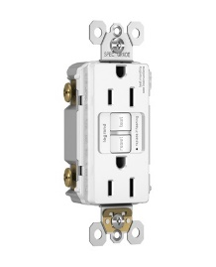 | 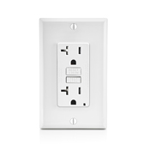
UL 943 - What does the standard say?
- All devices manufactured after June 2015 have to have an automatic ground fault self-testing feature. If a problem is detected, power will be cut, or an indication must be given provided.
- New GFCIs must have a Line-Load Reversal Function – If the GFCI is miswired (Line to Load terminals), it will not reset or power until it is properly wired.
Other less common facts of the change:
- Any products manufactured prior to this new standard are grandfathered to the old standard. The pre-standard parts maybe sold, or installed with no restrictions or phase out.
- Due to the new requirements, the price of the new receptacles can run up to 40% higher than the current self-test models
- Sunrise Electric can help you meet these requirements with Leviton and Pass & Seymour devices

UL/ETL Certified Bridgeport Transition Fittings  Save time and money with the newly ETL/UL certified Bridgeport Transition fittings. This new product line allows makes the transition between dissimilar systems a breeze while maintaining the integrity as required by the National Electrical Code.  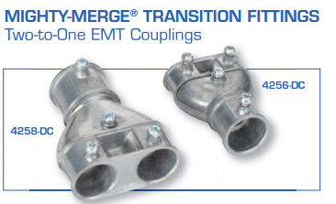 | 